Consulting Solutions SQL CLASS SETUP
(using the USB thumb drive)

Contents
Copy Files from USB(CD) to your Hard Drive 2
Install Oracle Database 3
SQL Developer Setup 4
Create System Connection in SQL Developer 5
Create Two Users in Database using SQL Developer 6
Create books1 Connection to Database in SQL Developer 6
Create cruises1 Connection to Database in SQL Developer 7
Load books1 tables 8
Load cruises1 tables (there are two files) 9
Some Useful SQL Links 11

Copy Files from USB(CD) to your Hard Drive
- Confirm you have the following files on your hard drive:
  - OracleXE112_WinZip32.zip
  - sqldeveloper-3.2.10.09.57.zip
  - BookStore.sql
  - Create_EFCodd_Version_X_Script_01.sql
  - Create_EFCodd_Version_X_Script_02.sql
  - Note1: You may also have a free version of WinZip on the thumb drive. There are two files on the thumb drive that require unzipping (extracting). See where to unzip in the instructions below. Your computer may have this already, in which case you will not need to use this file and will not need to copy it to your hard drive. If you do not know how to use WinZip please visit their website http://kb.winzip.com/kb/ for instructions or search Google.
  - Note2: If you do not see the file extensions on the files above and want to turn that feature on please visit: http://windows.microsoft.com/en-US/windows-vista/show-or-hide-file-name-extensions to learn how or search Google.

- Create directory C:\oracleclass on your hard drive
- Copy file OracleXE112_WinZip32.zip from USB to c:\oracleclass
- Copy file sqldeveloper-3.2.10.09.57.zip from USB to c:\oracleclass
- Copy following three files from USB to c:\oracleclass
  - BookStore.sql
  - Create_EFCodd_Version_X_Script_01.sql
  - Create_EFCodd_Version_X_Script_02.sql

Install Oracle Database
- Unzip (extract) c:\oracleclass\OracleXE112_WinZip32.zip into c:\oracleclass\OracleXE112_WinZip32\
- Create folder c:\oraclexe on your hard drive
- Browse to find c:\oracleclass\OracleXE112_WinZip32\Disk1\Setup.exe
- Right-Click on Setup.exe
- Choose Run as Administrator
- Confirm it is installing into C:\oraclexe
- IMPORTANT: WHEN PROMPTED FOR A PASSWORD ENTER> admin
- After it completes the installation Reboot your PC
- Find icon on desktop: Get Started with Oracle 11g Express Edition > Click to launch
- Browser will start and desired outcome shown here:

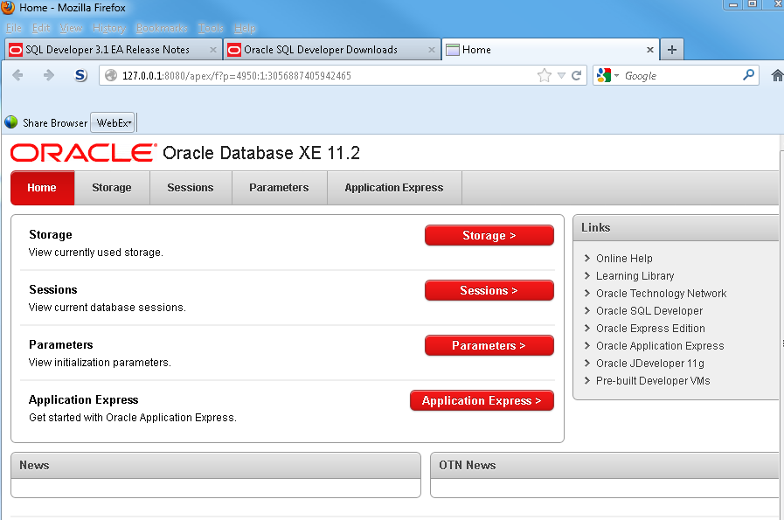

- Close browser

SQL Developer Setup
- Unzip (extract) c:\oracleclass\sqldeveloper-3.2.10.09.57.zip into c:\oracleclass\sqldeveloper-3.2.10.09.57\
- Browse to c:\oracleclass\sqldeveloper-3.2.10.09.57\sqldeveloper\sqldeveloper.exe
- Launch sqldeveloper.exe
- Desired outcome shown below
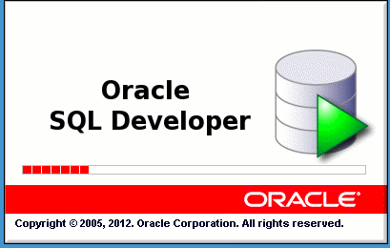

Create System Connection in SQL Developer
- Open SQL Developer
- Click on the Green Plus sign top left
- Create the connection for system
  - Connection Name: System
  - Username: System
  - Password: admin

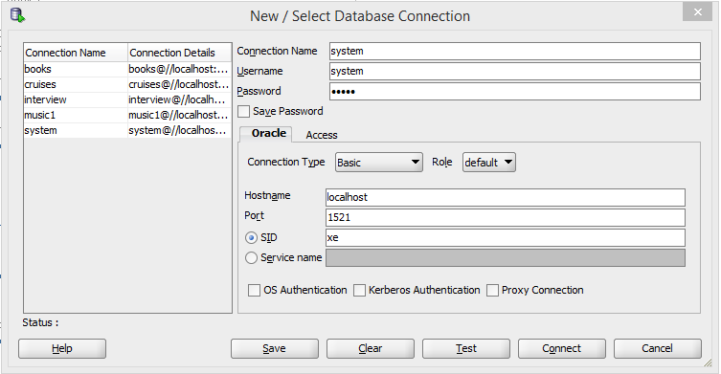

- Click Test
- Confirm Status: Success
- Click Connect

Create Two Users in Database using SQL Developer
- You are now in SQL Developer
- Make sure that System is showing in the top right
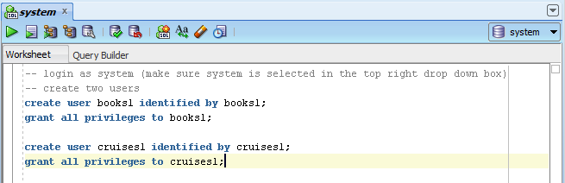

- Type in the commands you see here
- At the end of each line make sure you have a semi-colon
- Click Ctrl-Enter to execute each line

Create books1 Connection to Database in SQL Developer
Connection 1: books1
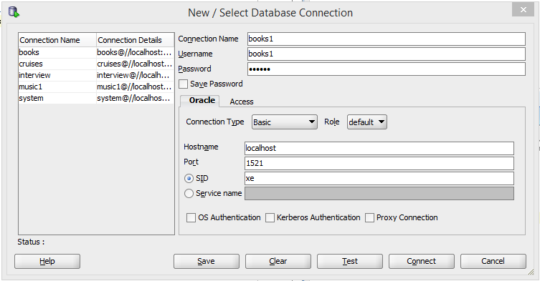

- Open SQL Developer
- Click on the Green Plus sign top left
- Create the connection for books1
  - Connection Name: books1
  - Username: books1
  - Password: books1
- Click Test
- Confirm Status: Success
- Click Connect

Create cruises1 Connection to Database in SQL Developer
Connection 2: cruises1
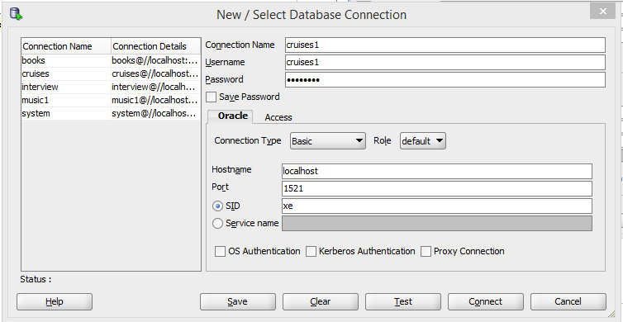
- Open SQL Developer
- Click on the Green Plus sign top left
- Create the connection for books1
  - Connection Name: cruises1
  - Username: cruises1
  - Password: cruises1
- Click Test
- Confirm Status: Success
- Click Connect

Load books1 tables
- Open SQL Developer
- File>Open>bookstore.sql
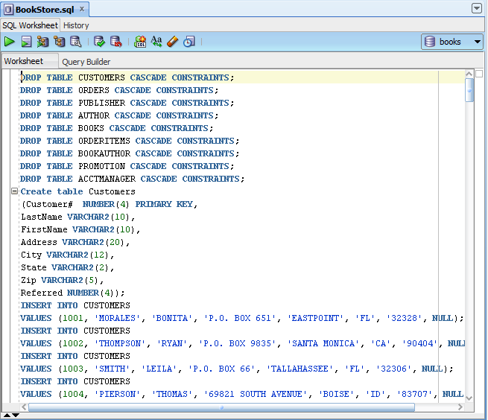
- Make sure books1 is selected in top right drop down
- Click your cursor in the window above with all the SQL commands
- Click CTRL-a (to select all)
- Click CTRL-Enter (to execute all the commands)
- In the left hand window click on the plus sign next to books1
- Then click on the plus sign next to tables
- Confirm you have about 8 tables

Load cruises1 tables (there are two files)
File 1: Create_EFCodd_Version_X_Script_01.sql
- Open SQL Developer
- File>Open> Create_EFCodd_Version_X_Script_01.sql
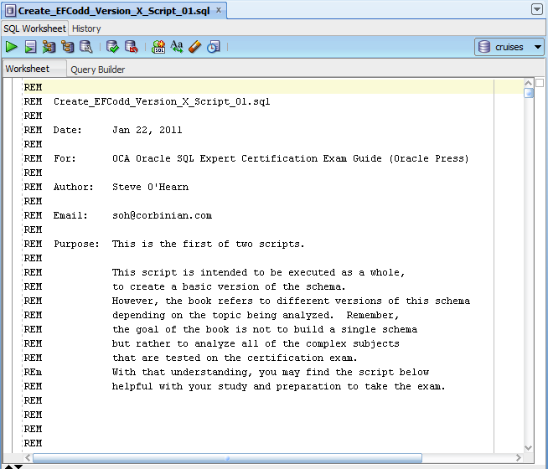
- Make sure cruises1 is selected in top right drop down
- Click your cursor in the window above with all the SQL commands
- Click CTRL-a (to select all)
- Click CTRL-Enter (to execute all the commands)
- In the left hand window click on the plus sign next to cruises1
- Then click on the plus sign next to tables
- Confirm you have about 15-20 tables

File 2: Create_EFCodd_Version_X_Script_02.sql
- Open SQL Developer
- File>Open> Create_EFCodd_Version_X_Script_01.sql
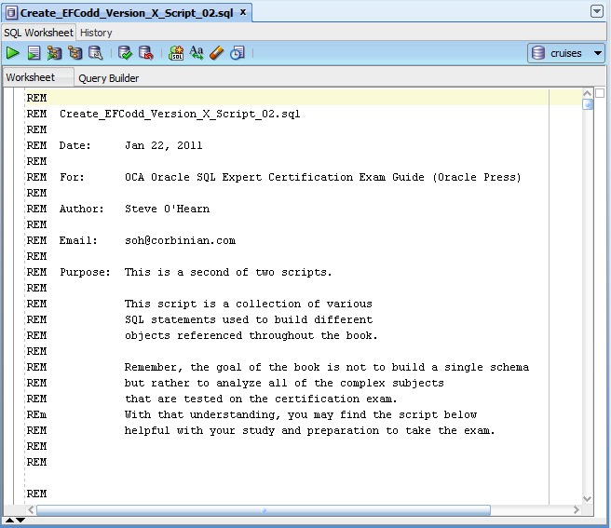
- Make sure cruises1 is selected in top right drop down
- Click your cursor in the window above with all the SQL commands
- Click CTRL-a (to select all)
- Click CTRL-Enter (to execute all the commands)
- In the left hand window click on the plus sign next to cruises1
- Then click on the plus sign next to tables
- Confirm you have about 35 tables

Some Useful SQL Links
The last two I do not know much about but the first three I use regularly.
- TechOnTheNet:
http://www.techonthenet.com/
- Don Burleson’s site:
http://www.dba-oracle.com
- Tom’s site:
http://asktom.oracle.com
- PSOUG:
http://www.psoug.org/
- Online SQL course support materials:
www.sqlcourse.com/

